**Student Name: Hari Krishnan Nair**

**UID: 20BCS2000**

**Branch: CSE Section: 903 WWDC 43**

**Semester: 5th**

**Worksheet 4 (It skills)**

**Q1. That Is my Score!**

**Code:**

#include <iostream>

using namespace std;

int main() {

int t;

cin>>t;

while(t--){

int n;

cin>>n;

int p[n],s[n];

int sum=0;

for(int i=0; i<n; i++){

cin>>p[i]>>s[i];

}

for(int i=1; i<9; i++){

int max=0;

for(int j=0; j<n; j++){

if(i==p[j] && s[j]>max){

max=s[j];

}

}

sum = sum+max;

}

cout<<sum<<endl;

}

return 0;

}

**OUTPUT:**

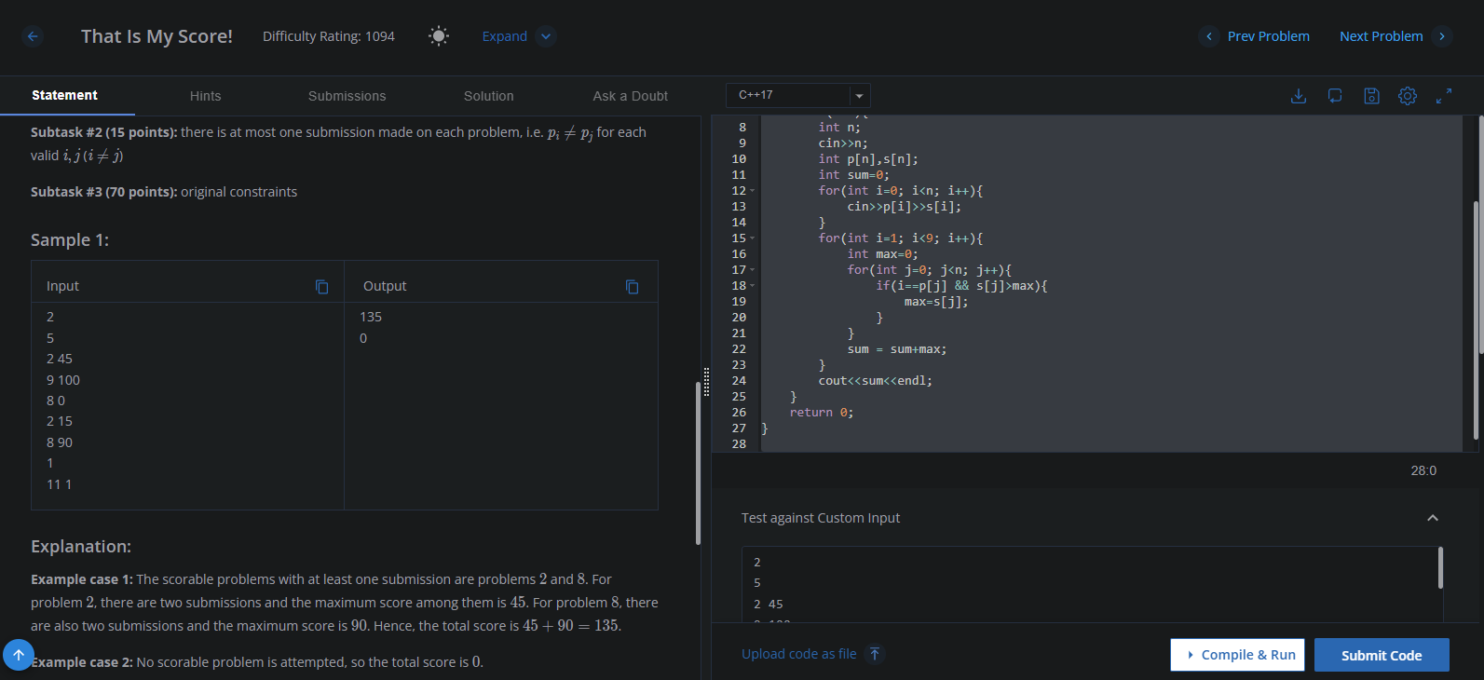

**Q2. Temple Land**

**Code:**

#include <iostream>

using namespace std;

int main() {

int t;

cin>>t;

while(t--)

{

int n;

cin>>n;

int arr[n];

for(int i=0;i<n;i++)

cin>>arr[i];

if(n%2==0 || arr[0]!=1 || arr[n-1]!=1)

cout<<"no"<<endl;

else

{

int flag=0;

int mid=n/2;

for(int i=0;i<mid;i++)

{

if(arr[i]+1!=arr[i+1])

flag++;

}

for(int i=mid;i<n-1;i++)

{

if(arr[i]-1!=arr[i+1])

flag++;

}

if(flag==0)

cout<<"yes"<<endl;

else

cout<<"no"<<endl;

}

}

return 0;

}

**OUTPUT:**

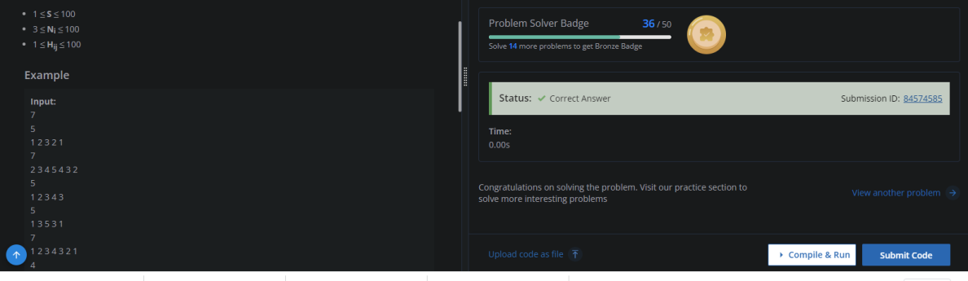

**Q3. Pairwise AND Sum**

**Code:**

#include <bits/stdc++.h>

using namespace std;

int main() {

// your code goes here

long sum[30] = {};

int N,a;

long ans = 0;

cin>>N;

for(int i=0; i<N; i++){

cin>>a;

ans-=a;

for(int j=0; a; a=a>>1, j++){

if(a&1) sum[j]++;

}

}

for(int j=0; j<30; j++){

ans+=(sum[j]*sum[j])<<j;

}

cout<<ans/2<<endl;

return 0;

}

**OUTPUT:**

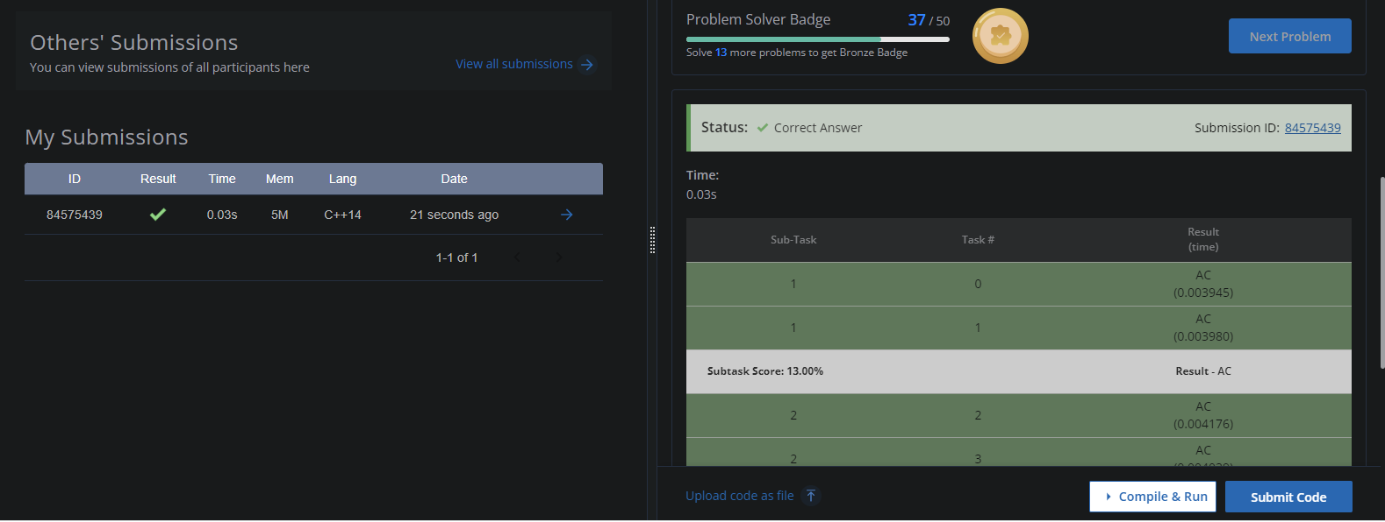

**Q4.** **Roads in Chef land**

**Code:**

#include<bits/stdc++.h>

using namespace std;

void solve()

{

int n;

cin>>n;

if((n&(n-1))==0)

{

cout<<-1<<endl;

return;

}

long long ans=0;

for(int i=1; i<=n; i<<=1)

ans+=((n-i)/(i<<1))*i;

for(int i=2; i<n; i<<=1)

ans+=i;

cout<<ans<<endl;

}

int main()

{

int t;

cin>>t;

while(t--)

{

solve();

}

return 0;

}

**OUTPUT:**



**Q5. The Array Problem**

**Code:**

#include<iostream>

using namespace std;

int main()

{

int n;

cin>>n;

int a[n][n];

for(int i=0;i<n;i++)

{

for(int j=0;j<n;j++)

{

cin>>a[i][j];

}

}

int counter=0;

int r=0;

int j=0;

while(r<(n))

{

int k=0;

while(k<n)

{

for(int i=0;i<n;i++)

{

for(j=r;j<n;j++)

{

if(a[r][k]>a[j][i])

{

int t;

t=a[r][k];

a[r][k]=a[j][i];

a[j][i]=t;

counter++;

}

}

k++;

}

}

int m=0;

while(m<n)

{

for(int i=0;i<n;i++)

{

for(j=r;j<n;j++)

{

if(a[m][r]>a[i][j])

{

int p=a[m][r];

a[m][r]=a[i][j];

a[i][j]=p;

counter++;

}

}

m++;

}

}

r++;

j++;

}

cout<<counter<<endl;

for(int i=0;i<n;i++)

{

for(int j=0;j<n;j++)

{

cout<<a[i][j]<<" "; }

}

}

**OUTPUT:**

